Diameter
# Source: AI Source: Provided by: [Data Path: Persons Table -> ID Column: 1, Name_En Column: Motasem Essam] -> From: [ChatGPT] on [7/25/2026]
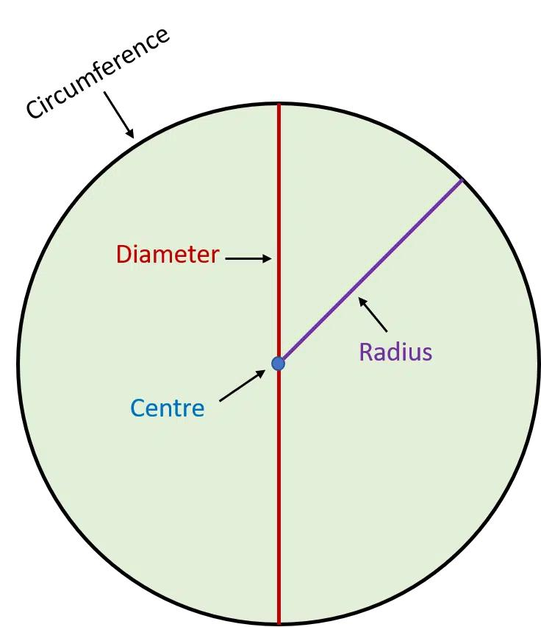
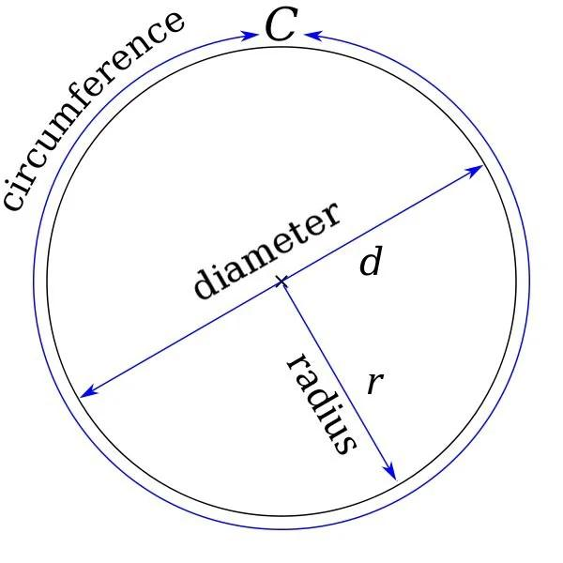
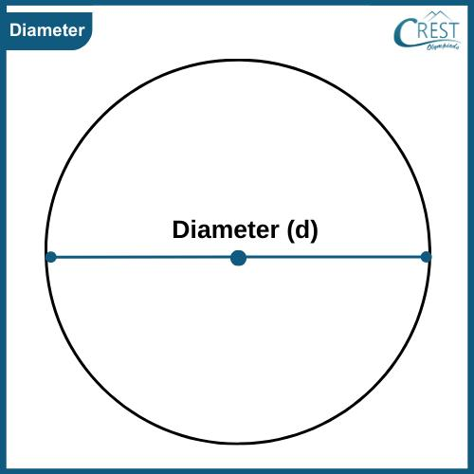
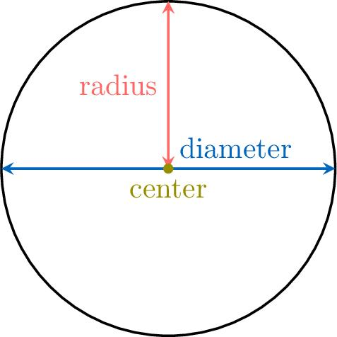
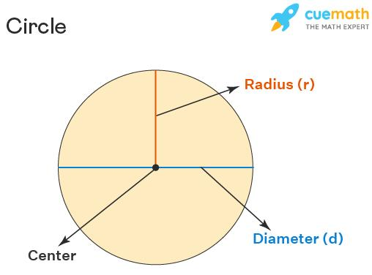

Definition
# Source: AI Source: Provided by: [Data Path: Persons Table -> ID Column: 1, Name_En Column: Motasem Essam] -> From: [ChatGPT] on [7/25/2026]
The diameter of a circle is a line segment that passes through the center of the circle and has both endpoints on the circumference.
The diameter is usually denoted by:
$$d$$
If $O$is the center and $A$and $B$are points on the circle, then:
$$\overset{‾}{AB}$$
is a diameter when $O$lies on $\overset{‾}{AB}$.

Fundamental Elements
# Source: AI Source: Provided by: [Data Path: Persons Table -> ID Column: 1, Name_En Column: Motasem Essam] -> From: [ChatGPT] on [7/25/2026]
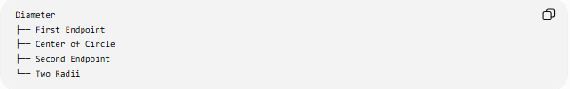
Diameter
├── First Endpoint
├── Center of Circle
├── Second Endpoint
└── Two Radii
A diameter consists of two radii placed end-to-end.
$$\boxed{d=2r}$$
and therefore:
$$\boxed{r=\frac{d}{2}}$$
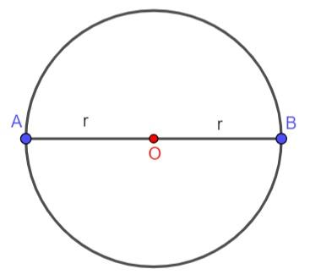
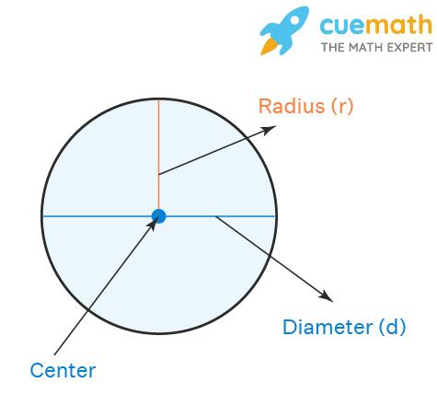
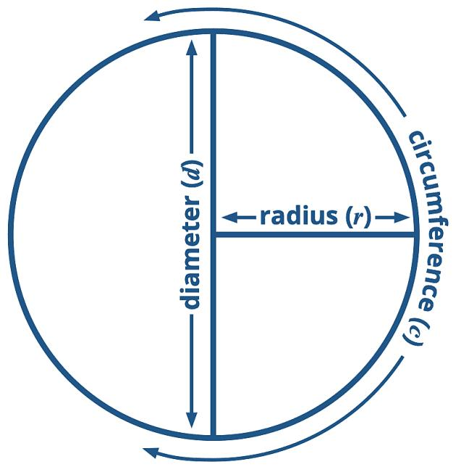
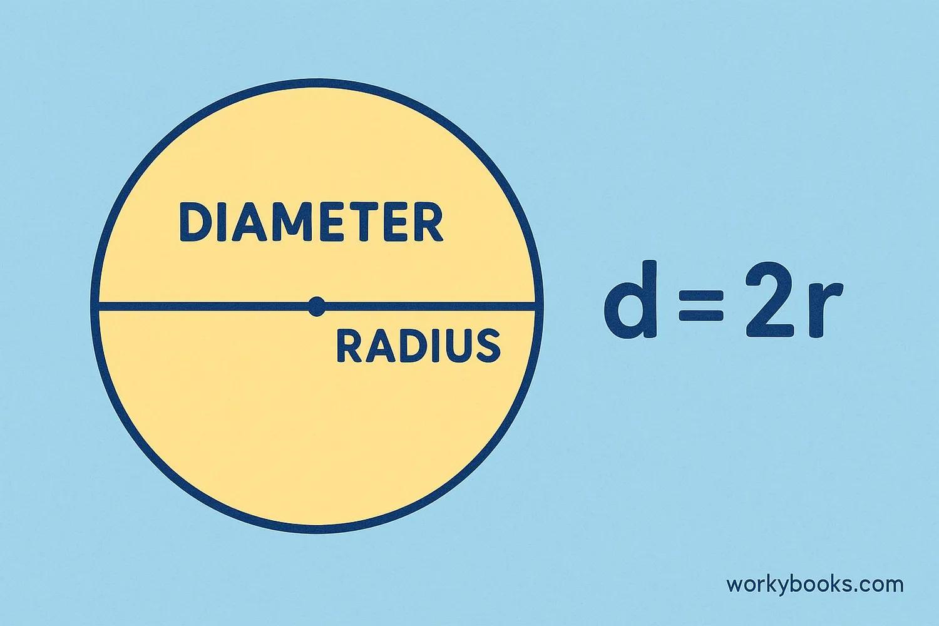

Main Properties
# Source: AI Source: Provided by: [Data Path: Persons Table -> ID Column: 1, Name_En Column: Motasem Essam] -> From: [ChatGPT] on [7/25/2026]
- A diameter passes through the center of the circle.
- Both endpoints lie on the circumference.
- Every diameter has the same length within the same circle.
- A diameter is the longest chord of a circle.
- A circle has infinitely many diameters.
- Every diameter divides the circle into two equal semicircles.
- A diameter is twice the radius.

Diameter and Radius
# Source: AI Source: Provided by: [Data Path: Persons Table -> ID Column: 1, Name_En Column: Motasem Essam] -> From: [ChatGPT] on [7/25/2026]
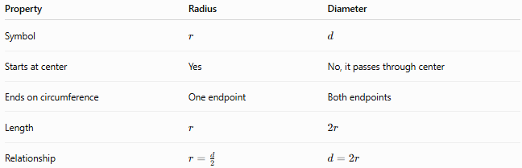
Property | Radius | Diameter
Symbol | $$r$$ | $$d$$
Starts at center | Yes | No, it passes through center
Ends on circumference | One endpoint | Both endpoints
Length | $$r$$ | $$2r$$
Relationship | $$r=\frac{d}{2}$$ | $$d=2r$$

Diameter and Chord
# Source: AI Source: Provided by: [Data Path: Persons Table -> ID Column: 1, Name_En Column: Motasem Essam] -> From: [ChatGPT] on [7/25/2026]
Every diameter is a chord, but not every chord is a diameter.
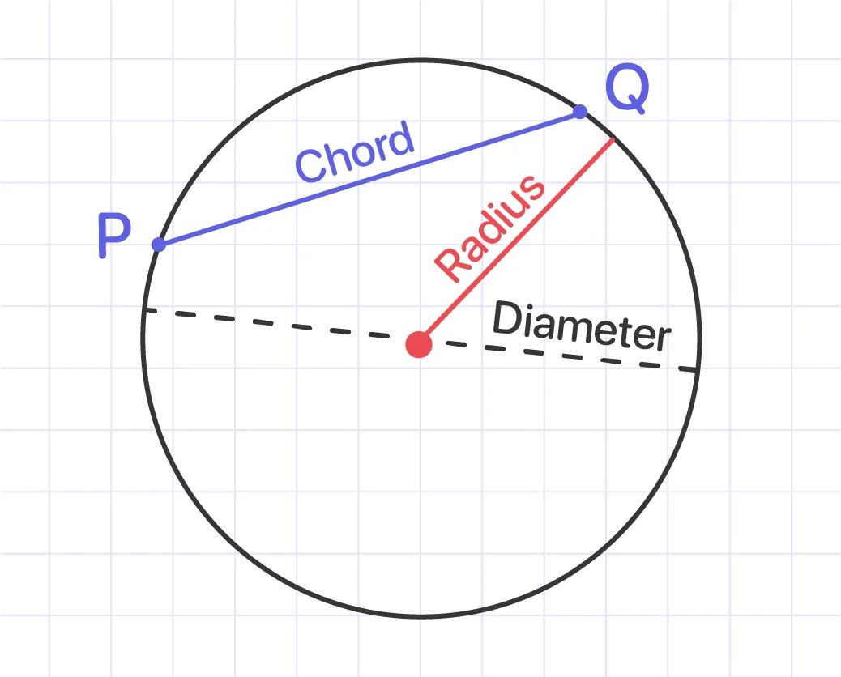
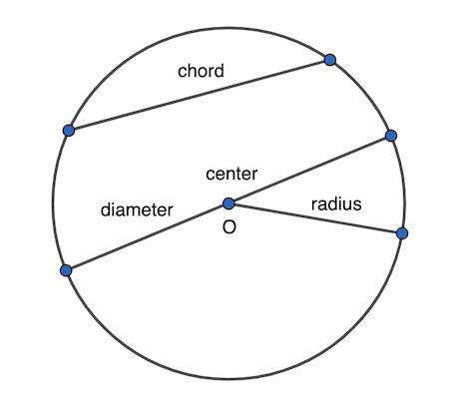
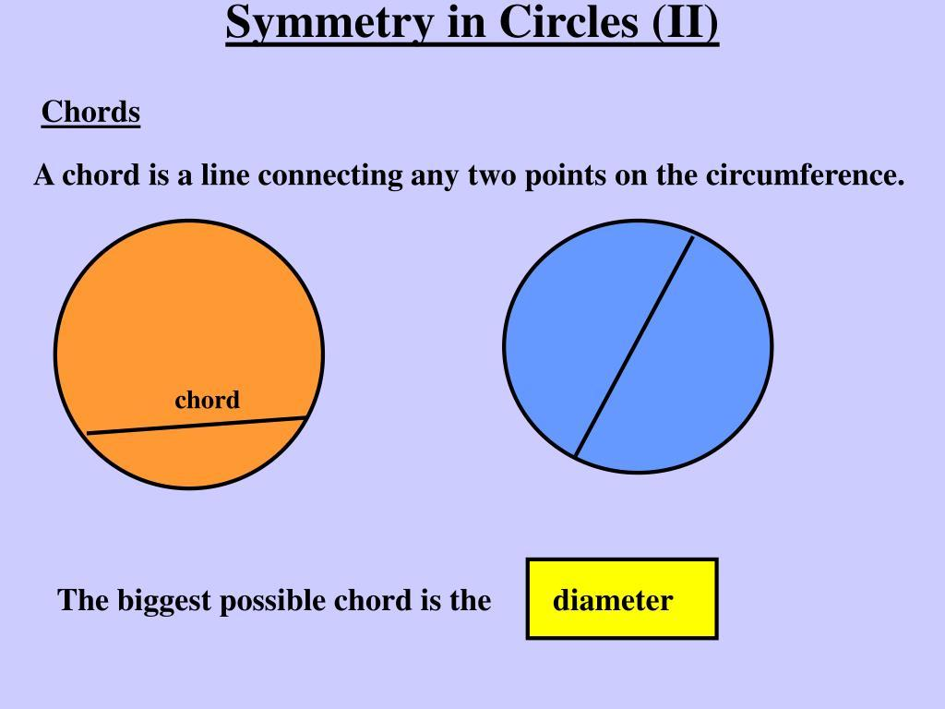
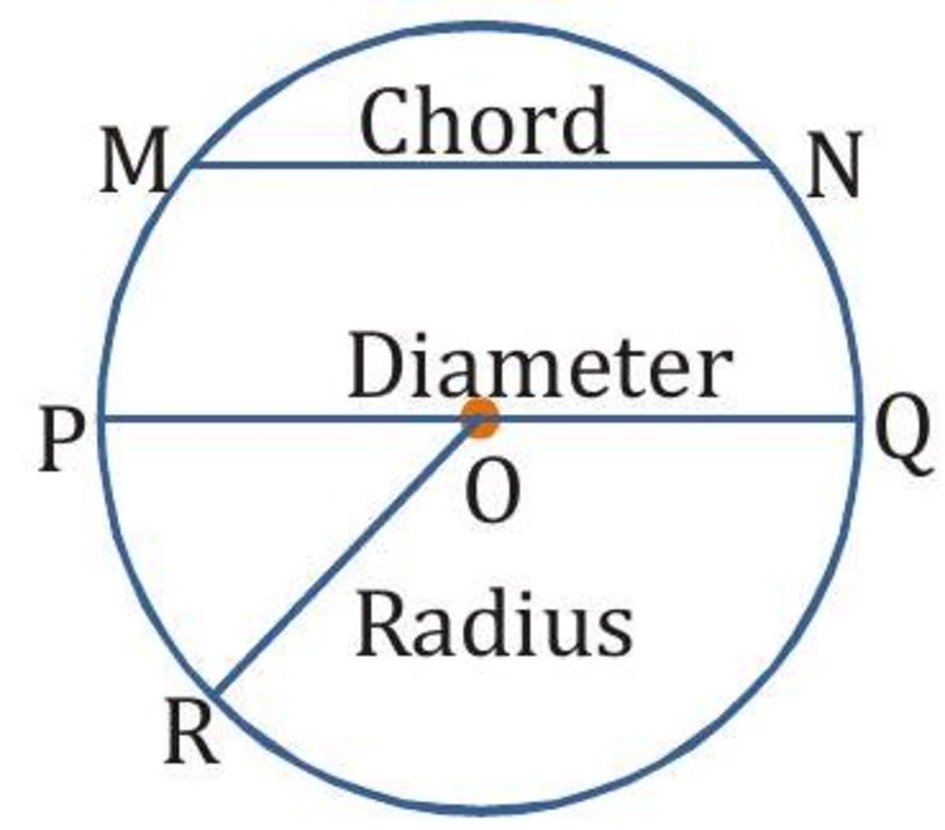
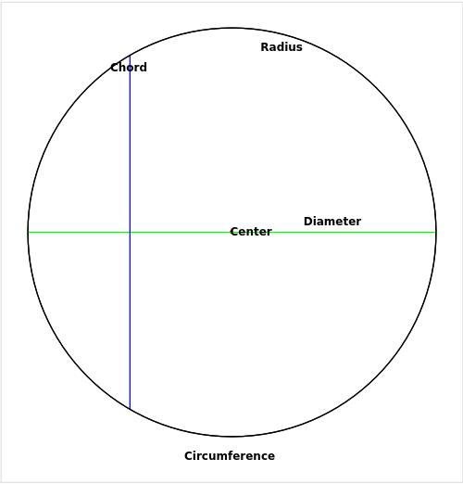
- Chord: Any segment whose endpoints lie on the circumference.
- Diameter: A special chord that passes through the center.
Therefore:
$$\boxed{\text{Diameter}⊂\text{Chord}}$$

Mathematical Applications
# Source: AI Source: Provided by: [Data Path: Persons Table -> ID Column: 1, Name_En Column: Motasem Essam] -> From: [ChatGPT] on [7/25/2026]
Circumference
Since $d=2r$:
$$C=2πr$$
can also be written as:
$$\boxed{C=πd}$$
Area
Since $r=\frac{d}{2}$:
$$A=πr^{2}$$
becomes:
$$\boxed{A=\frac{πd^{2}}{4}}$$
Example
If the radius of a circle is:
$$r=7\text{ cm}$$
then:
$$d=2r \\ d=2\left(7\right)=\boxed{14\text{ cm}}$$
Its circumference is:
$$C=πd=14π\text{ cm}$$
and its area is:
$$A=\frac{π{\left(14\right)}^{2}}{4}=49π{\text{ cm}}^{2}$$

Special Relationship: Angle in a Semicircle
# Source: AI Source: Provided by: [Data Path: Persons Table -> ID Column: 1, Name_En Column: Motasem Essam] -> From: [ChatGPT] on [7/25/2026]
An angle subtended by a diameter at any point on the circumference is a right angle.
This is known as Thales' theorem:
$$\boxed{∠ACB={90}^{∘}}$$
when $AB$is a diameter.
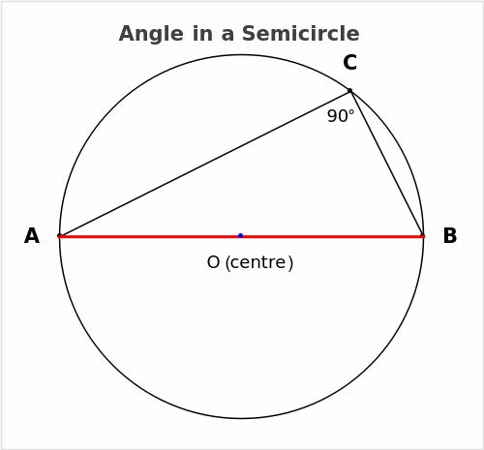
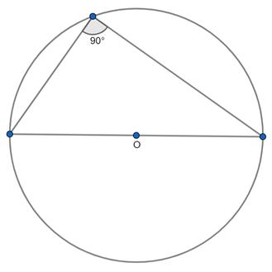
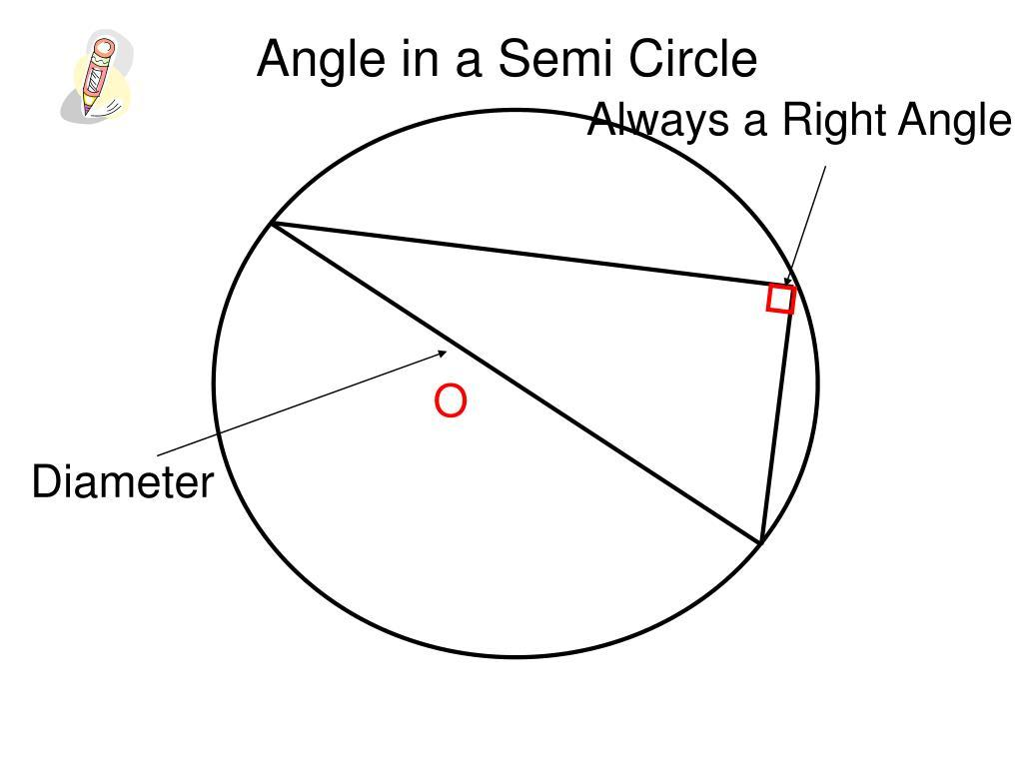
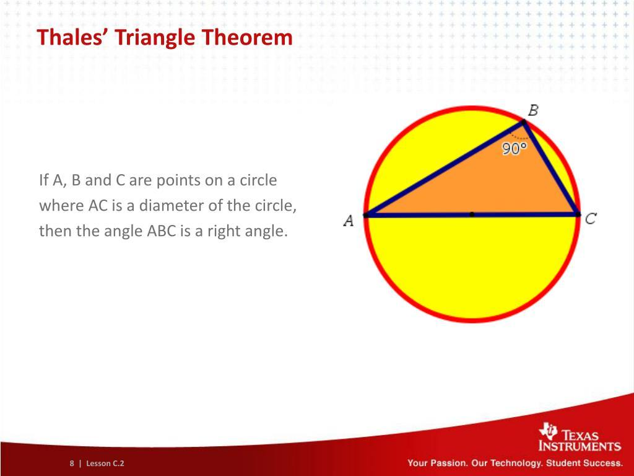
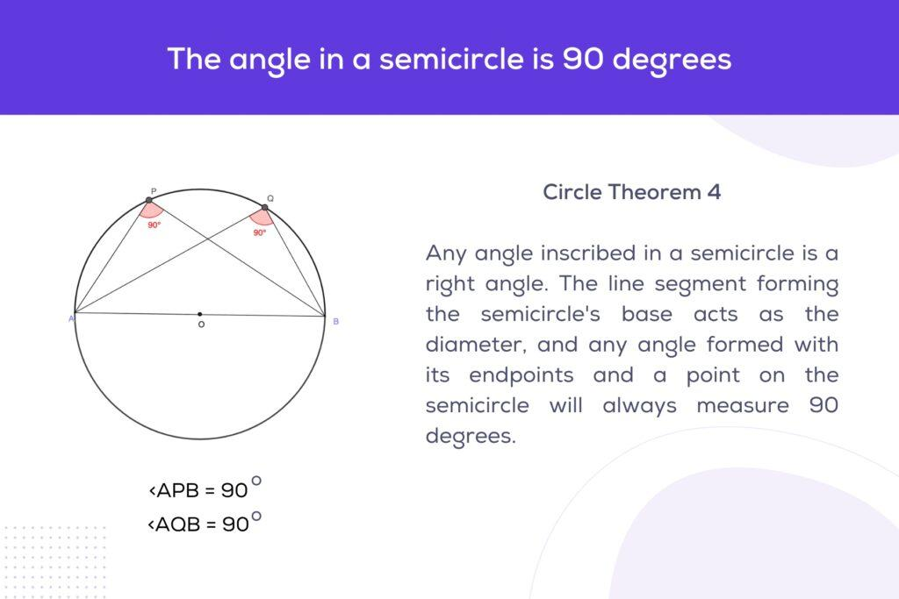

Related Concepts
# Source: AI Source: Provided by: [Data Path: Persons Table -> ID Column: 1, Name_En Column: Motasem Essam] -> From: [ChatGPT] on [7/25/2026]
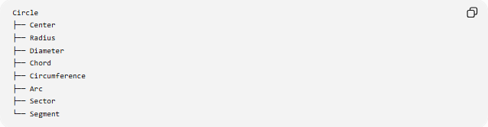
Circle
├── Center
├── Radius
├── Diameter
├── Chord
├── Circumference
├── Arc
├── Sector
└── Segment

Key Points
# Source: AI Source: Provided by: [Data Path: Persons Table -> ID Column: 1, Name_En Column: Motasem Essam] -> From: [ChatGPT] on [7/25/2026]
- Diameter = chord passing through the center.
- It is the longest chord of a circle.
- It equals two radii:
$$\boxed{d=2r}$$
- It divides a circle into two equal semicircles.
- Circumference can be calculated using:
$$\boxed{C=πd}$$
- Area can be calculated from the diameter using:
$$\boxed{A=\frac{πd^{2}}{4}}$$

Conclusion
# Source: AI Source: Provided by: [Data Path: Persons Table -> ID Column: 1, Name_En Column: Motasem Essam] -> From: [ChatGPT] on [7/25/2026]
The diameter is one of the fundamental measurements of a circle. It connects the circle's center to both sides of its circumference and provides a direct relationship between the radius, circumference, area, chords, and semicircles.

